Light ray

Jamie has bought a new torch.
On the packet there is a picture.
It shows how the torch makes a powerful beam.

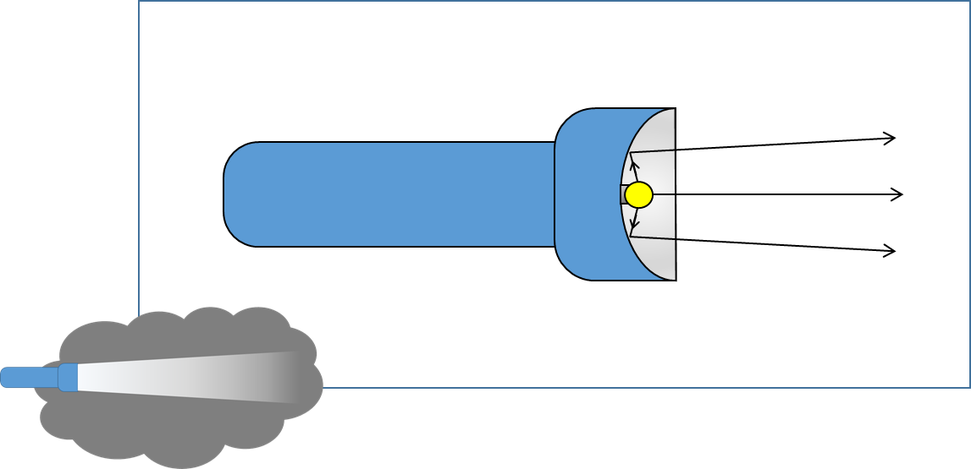

What do you know about the light rays shown in the picture?
For each statement, tick (✓) one column to show what you think.
 |  | I am sure this is right | I think this is right | I think this is wrong | I am sure this is wrong
A | A light ray is a long thin piece of light
B | Light is made of light rays added together
C | Light rays show the direction light moves

Physics > Big idea PSL: Sound, light and waves > Topic PSL3: Making images > Key concept PSL3.1: The ray model of light to explain images
Diagnostic question
Light ray

Overview
Learning focus: | Only some light rays from each point of an illuminated object can pass through a pinhole, hitting a screen at distinct points to make an inverted image.
Observable learning outcome: | Describe what a light ray represents.
Question type: | Confidence grid
Key words: | Light ray

What does the research say?
Galili and Hazan (2000) found over half of 14- to 16-year-olds (n=166) consider rays to be actual physical things that are the constituents of light. The fact that rays are imaginary lines that show the direction in which light is travelling is rarely made explicit in teaching (Andreou and Raftopoulos, 2011).
This question investigates students’ understanding of light rays.
Ways to use this question
Students should complete the confidence grid individually. This could be a pencil and paper exercise, or you could use an electronic ‘voting system’ or mini white boards and the PowerPoint presentation.
If there is a range of answers, you may choose to respond through structured class discussion. Ask one student to explain why they gave the answer they did; ask another student to explain why they agree with them; ask another to explain why they disagree, and so on. This sort of discussion gives students the opportunity to explore their thinking and for you to really understand their learning needs.
Differentiation
You may choose to read the questions to the class, so that everyone can focus on the science. In some situations it may be more appropriate for a teaching assistant to read for one or two students.
Expected answers
A and B are wrong
C is correct
A light ray is an imaginary line that shows the direction in which light is travelling.

How to respond - what next?
Light is electromagnetic radiation that is comprised of moving photons that are ‘packets’ of electrical and magnetic waves.
At his stage it is reasonable to say that a light ray is a direction arrow that represents one of the paths along which light moves. Misunderstandings about light rays often originate from teaching that does not make this explicit.
If students have misunderstandings about whether light is comprised of physical rays, it can help to discuss what arrows that show the path of a ball represent. Giving students the opportunity to use their own words to explain what rays of light represent helps consolidate understanding.
Acknowledgments
Developed by Peter Fairhurst (UYSEG)
Images: Peter Fairhurst (UYSEG)
References
Andreou, C. and Raftopoulos, A. (2011). Lessons from the history of the concept of the ray for teaching geometric optics. Science and Education, 20, 1007-1037.
Galili, I. and Hazan, A. (2000). Learners' knowledge in optics: interpretation, structure and analysis. International Journal of Science Education, 22(1), 57-88.

